**Lecture 8 Autoregressive and Moving Average Models**

In this talk, statistical models for stationary time series are introduced. We begin with ***autoregressive*** ***(AR)*** processes which have a direct interpretation in terms of the linear regression. After the ***moving average*** ***(MA)*** processes we look at the mixed models. Finally the general ***ARIMA*** models are presented, which cover both stationary and non-stationary time series.

In the following discussion, {} is the observed time series – the stochastic component in the additive model (see Lecture 6) – and {} an unobserved white noise process with zero mean and variance .

**8.1 Autoregressive processes**

A time series {} is said to be a ***pth-order autoregressive process***, denoted as ***AR(p)***, if

 =  +  + … +  + .

That is,  is regressed on the past values , , …, . The “error”  is an innovation term and independent of , , …, . The coefficients ****, i = 1, 2, …, p, are called the ***φ-weights***. We pay particular attention to the low order AR models, AR(1) and AR(2), which are used widely in practice.

Note that not all AR processes are stationary. For instance, the random walk process is an AR(1) process and not stationary (see Example 6.9).

**Stationarity condition and *acf* for an AR(1) process:**

The AR(1) process is given by  = φ + .

The process is stationary if and only if |φ| < 1.

The acf is  = , for k = 0, 1, 2, …

Note that the *acf* decreases in absolute value exponentially. The following two figures show the AR(1) autocorrelation functions when φ < 0 and φ > 0, respectively.

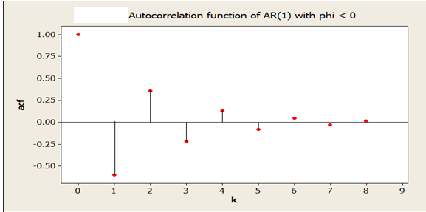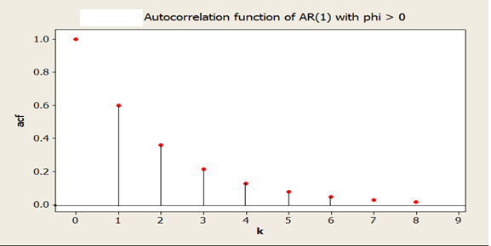

**Stationarity condition and *acf* for an AR(2) process:**

The AR(2) process is given by  =  +  + .

The process is stationary if and only if  +  < 1,  -  < 1 and || < 1.

The acf is given by

 = 

 =  +  = 

 =  + , k = 3, 4, …

The figures below demonstrate the AR(2) autocorrelation functions for various values of  and .

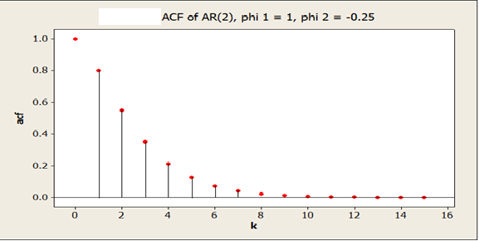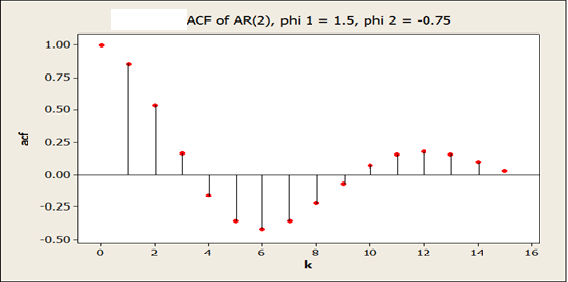

**8.2 Moving average processes**

A time series {} is said to be a ***moving average process******of order q*,** denoted as ***MA(q)***, if

 =  -  -  - … - .

Note that the process is stationary and  is represented as a linear combination of the present and a finite number of past terms of a white noise. The coefficients , i = 1, 2, …, q, are called the ***θ-weights***. AgainWe pay particular attention to the low order MA models, such as MA(1) and MA(2) though MA(3) is also frequently used in practice.

# The acf of MA(1) process:

The MA(1) process is given by  =  - 

The *acf* is  =  and  = 0, for k ≥ 2.

# The acf of MA(2) process:

The MA(1) process is given by  =  -  - 

The *acf* is given by

 = ,  = ,  = 0, for k ≥ 3.

**8.3 Autoregressive-moving average processes**

A time series {} is said to be a ***mixed autoregressive-moving average process of order p and q***, denoted as ***ARMA(p, q)***, if

 =  +  + … +  +  -  -  - … - .

For a stationary ARMA(1, 1) process,

 = φ +  - θ, |φ| < 1,

the *acf* is given by

 =  , k = 1, 2, …

The figures below exhibit the ARMA(1, 1) autocorrelation functions for some values of θ and φ.

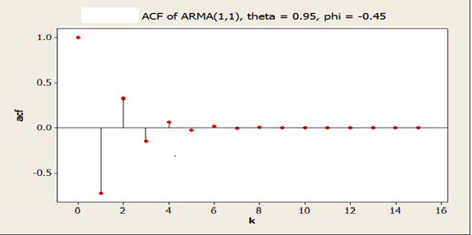

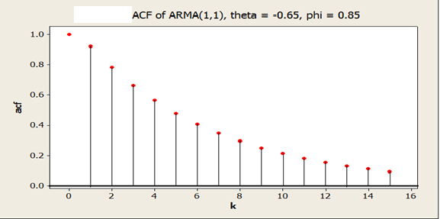

# 8.4 The ARIMA models

# The difference operator ∇: For a process {}, define the first-order difference as

∇ =  - ,

and the second-order difference as

∇ = ∇(∇) =  - 2 + ,

and so on.

**Achieving stationarity through differencing:** Consider an AR(2) model

 = 1.5 - 0.5 + .

This process is not stationary. Let  = ∇. Then

 = 0.5 + .

We notice that the differenced process {} is stationary.

A process {} is said to be an ***integrated autoregressive-moving average process****, denoted by* ***ARIMA(p, d, q)****,* if the *d*th difference  = ∇ is a stationary ARMA(p, q) process. Several commonly used models are as follows.

***ARIMA(0, 1, 1)*** or ***IMA(1, 1)***: If {} is an ARIMA(0, 1, 1) process, then {∇} is an MA(1) process. Thus

 -  =  - θ

or  =  +  - θ.

***ARIMA(0, 2, 2)*** or ***IMA(2, 2)***: If {} is an ARIMA(0, 2, 2) process, then {∇} is an MA(2) process. Therefore

 - 2 + =  -  - 

or  = 2 -  +  -  - .

***ARIMA(1, 1, 0)*** or ***ARI(1, 1)***: If {} is an ARIMA(1, 1, 0) process, then {∇} is a stationary AR(1) process. Therefore

 -  = φ( - ) + 

or  = (1 + φ) - φ + , where |φ| < 1.

**Exercises**

8.1 Sketch the acfs for each of the following ARMA models:

1. AR(2) with  = 1.2 and  = -0.7.
2. MA(2) with  = 1.2 and  = -0.7.
3. ARMA(1, 1) with φ = 0.7 and θ = 0.4.

8.2 Describe the important characteristics of the acfs for the following models:

MA(1), MA(2), AR(1), AR(2), and ARMA(1, 1).

8.3 Identify each of the following models as a specific ARIMA model:

1.  =  - 0.25 +  + 0.5
2.  = 2 -  + 
3.  = 0.5 + 0.5 +  - 0.5 + 0.25

**References**

* Chatfield, C. (2004), *The Analysis of Time Series: An Introduction*, CHAPMAN & HALL.
* Cryer, J. D. (1986), *Time Series Analysis*, PWS-KENT.
* Millard, S.P. and Neerchal, N. K. (2000), *Environmental Statistics with S-PLUS*, Chapman & Hall.

8.3

i. arima(2, 0, 1)

2. arima(2, 0, 0)

iii. arima(2, 0, 2)